Task Planner App by Osten and Monica

**On iPhone:**

**Shared link** (can play preview – click blue dots):<https://ninjamock.com/s/H2V31Gx>

Home:

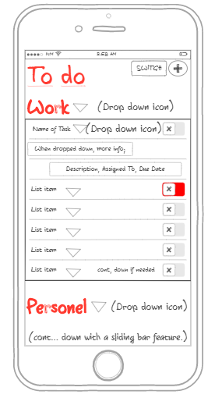

Home- Done:

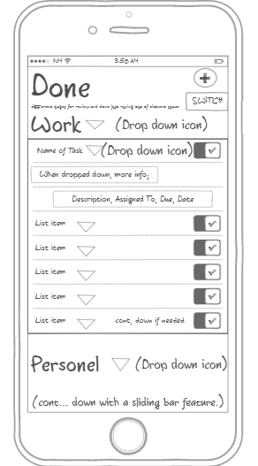

Fill in details:

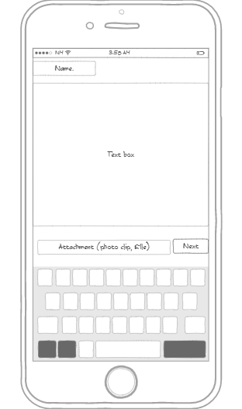

Fill in 2:

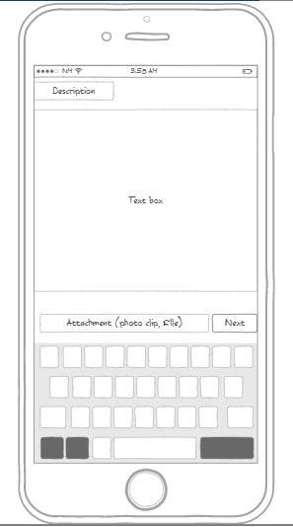

Fill in 3:

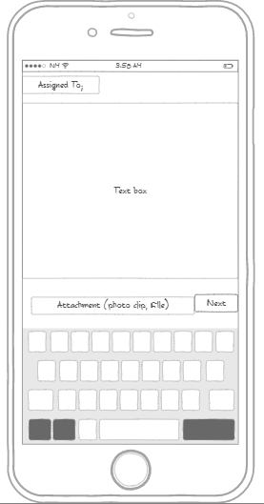

Fill in 4:

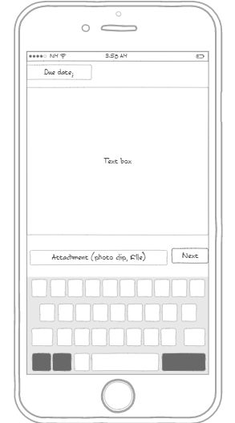

Fill in 5:

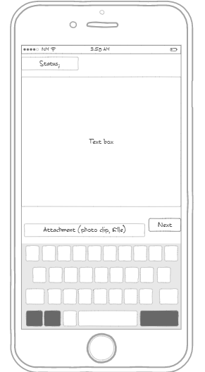

Fill in 6:

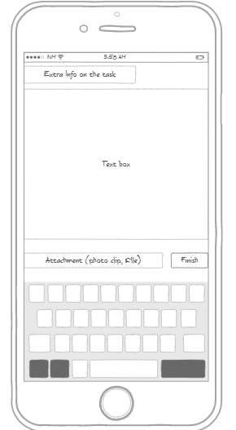

**On Windows Desktop:**

Shared link: <https://ninjamock.com/s/6S331Gx>

Home:

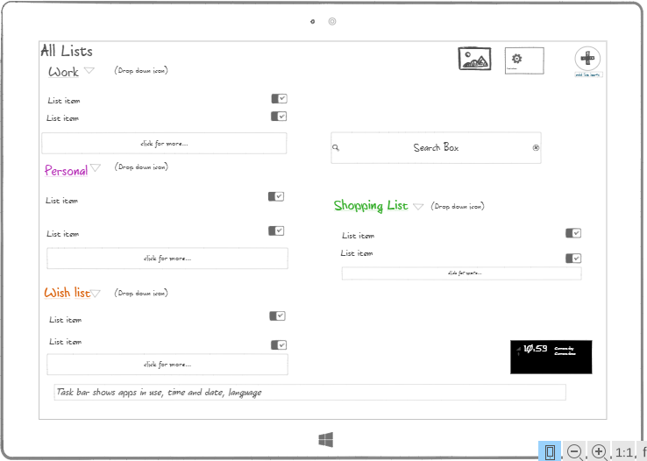

Fill in details:

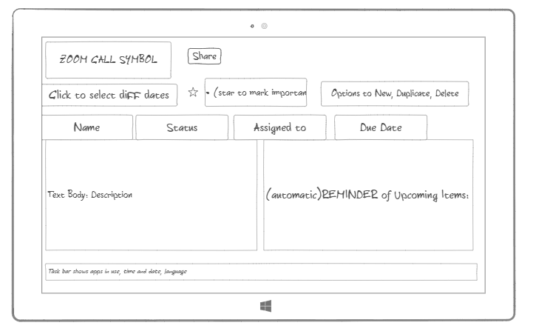

Home – in progress

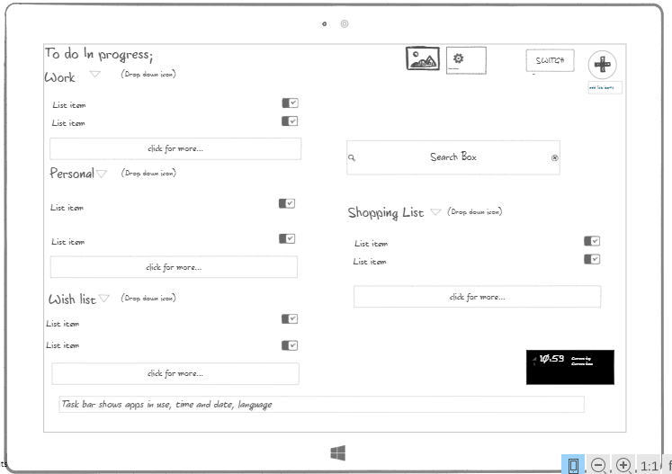

Home – Done Lists

